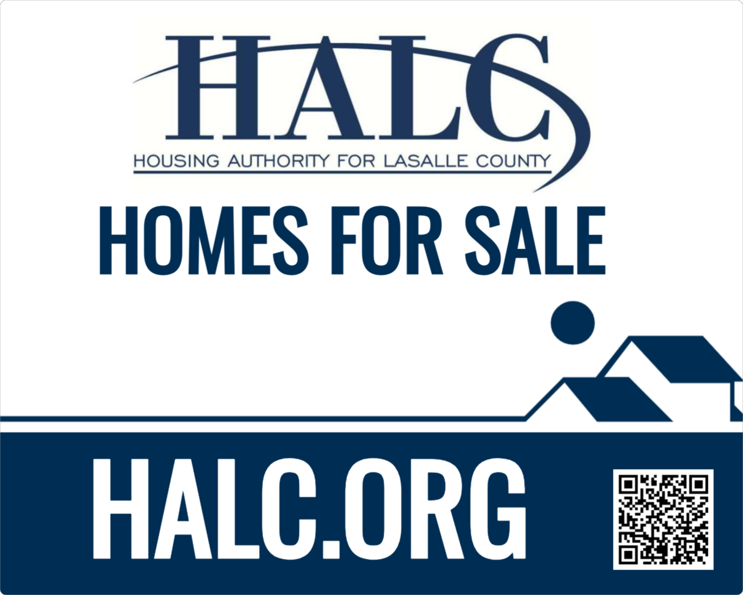
NOTICE OF PUBLIC SALE

The Housing Authority for LaSalle County (HALC) will offer for sale to the highest bidder one (1) single family home property listed on Exhibit A of this notice.

This property is owned by the Housing Authority for La Salle County but encumbered through a Declaration of Trust (DOT) by the U.S. Department of Housing and Urban Development (HUD). Pursuant to HUD regulations, HALC has established a minimum bid price for this property based on appraised value in current “as-is” condition. Offers cannot be considered for any amount less than the established minimum bid amount listed on Exhibit A.

Instructions for Bidding
Bids must be submitted no later than: Friday, July 31, 2026, at 9:00 AM at
526 E Norris Dr. Ottawa, IL 61350

PUBLIC BID OPENING
All bids received shall be publicly opened and recorded Friday, July 31, 2026, at 10:00 AM at the Parkview Homes Community Center located at 1810 Seneca Drive, Ottawa, Illinois.

Interested bidders must complete the bid form in Exhibit B attached to this notice. The name of the bidder on Exhibit B shall be stated in the legal format desired for title upon consummation of the sale. The bid form shall be completed, signed and dated as indicated. Please list the property address exactly as listed on Exhibit A.

An earnest payment in the form of a cashier’s check, certified check or money order equal to 5% (five percent) of the total bid amount for each individual property bid upon (no combining bid checks) shall be addressed to: Housing Authority for LaSalle County and attached to the completed bid form.

Bid forms with corresponding earnest payments shall be presented in a sealed envelope. The envelope shall be clearly marked as follows:

Bid for Single Family Home
Housing Authority for LaSalle County
Address as listed on Exhibit A

Bids may be submitted via regular mail, overnight mail, or other similar means; or by personal delivery. Electronic submissions are not acceptable and will be rejected.

If delivering by method other than personal delivery, sealed bid envelopes shall be placed in a separate mailing envelope and mailed to:

ATTN: Steve Cooke
Housing Authority for LaSalle County
526 E. Norris Dr. PO Box 782
Ottawa, Illinois 61350

It shall be the sole responsibility of each bidder to ensure his/her bid(s) are received by HALC on or before the stipulated deadline.

Property Inspections – Properties will be available for inspection pursuant to the schedule attached in Exhibit C to this notice. Individuals who are unable to attend the date of inspection listed on the attached Exhibit C may request a viewing appointment by emailing a request to the email address below. A written confirmation will be returned via e-mail.

E-mail: scooke@halc.org

Bid Awards - Each property is being offered in “As Is, Where Is” condition with no express or implied warranties. The highest bid above the stated minimum bid will be accepted unless some unforeseen circumstance warrants rejection. In the event of equal high bids, the selection shall be randomly made by drawing lots immediately following the public bid opening.

Upon receipt of a valid bid, HALC shall provide the bidder with written confirmation of an acceptable bid and intent to sell. As noted on Exhibit B (bid form), bids must be held for a minimum of six months following the bid opening.

Earnest funds shall be returned within 15 business days from the date of bid opening for all bids that are not accepted.

Closing – As noted above, these properties are encumbered by HUD with a Declaration of Trust (DOT), and upon receipt of acceptable bids, HALC must secure approval from HUD to release the DOT. It is anticipated that this approval process could take from three to six months or longer. However, if approval is secured in less time, HALC will coordinate closings promptly upon receipt of HUD approval.

Conflict of Interest and Prohibited Bidders – In accordance with the United Stated Housing Act of 1937 (42U.S.C. 1437 et., al), as amended, and the Annual Contributions Contract (HUD-53012) Section 16:
(a) HAs shall maintain written standards of conduct covering conflicts of interest and governing the performance of its employees engaged in the selection, award and administration of contracts for which program receipts will be or are expended. No employee, officer, or agent shall participate in the selection, award, or administration of a contract supported by a Federal award if he or she has a real or apparent conflict of interest. Such a conflict of interest would arise when the employee, officer, or agent, any member of his or her immediate family, his or her partner, or an organization which employs or is about to employ any of the parties indicated herein, has a financial or other interest in or a tangible personal benefit from a firm considered for a contract. The HA’s procedures must avoid acquisition of unnecessary or duplicative items. The HA must disclose in writing any potential conflict of interest to HUD.
(b) The HA, its contractors and subcontractors shall not enter into any contract, subcontract, or arrangement in connection with a project under the CACC in which any of the following classes of people has an interest, direct or indirect, during his or her tenure or for one year thereafter:
1. Any present or former member or officer of the governing body of the HA, or any member of the officer's immediate family. There shall be excepted from this prohibition any present or former tenant commissioner who does not serve on the
governing body of a resident corporation, and who otherwise does not occupy a policymaking position with the resident corporation, the HA or a business entity.
2. Any employee of the HA who formulates policy or who influences decisions with respect to the Project(s), or any member of the employee's immediate family, or
the employee's partner.
3. Any public official, member of the local governing body, or State or local legislator, or any member of such individuals' immediate family, who exercises functions or responsibilities with respect to the project(s) or the HA.
4. Any member of these classes of persons must disclose the member's interest or prospective interest to the HA.
5. The requirements of this subsection may be waived by HUD for good cause, if the prohibited contract, subcontract or arrangement is otherwise permitted under State and local law. No person for whom a waiver is requested may exercise responsibilities or functions with respect to the contract, subcontract or arrangement to which the waiver pertains.
6. The provisions of this subsection (b) shall not apply to the General Depository Agreement entered into with an institution regulated by a Federal agency, or to
utility service for which the rates are fixed or controlled by a State or local agency.
(c) The HA shall not hire an employee in connection with a project under this ACC if the prospective employee is an immediate family member of any person belonging to one of the following classes:
1. Any present or former member or officer of the governing body of the HA. There shall be excepted from this prohibition any former tenant commissioner who
does not serve on the governing body of a resident corporation, and who does not occupy a policymaking position with the HA.
2. Any employee of the HA who formulates policy or who influences decisions with respect to the project(s).
3. Any public official, member of the local governing body, or State or local legislator, who exercises functions or responsibilities with respect to the project(s) or the HA.
(d) The prohibition referred to in subsection (c) shall remain in effect throughout the class member's tenure and for one year thereafter.
(e) A class member shall disclose to the HA the member's familial relationship to the prospective employee.
(f) For purposes of this section, the term "immediate family member" means: the spouse (including partners), mother, father, mother-in-law, father-in-law, brother, sister, brother-in-law, or sister-in-law, or child of a covered class member (whether related as a full blood relative, or as a "half" or "step" relative, e.g., a half-brother or stepchild).
(g) In addition to any other applicable conflict of interest requirements, including those provided herein, HAs must also maintain written standards of conduct covering conflicts of interest and governing the performance of its Board Member, executives, and employees engaged in the administration and operation of Projects covered by the CACC.
1. The officers, employees, and agents of the non-Federal entity must neither solicit nor accept gratuities, favors, or anything of monetary value from residents residing in Projects or participating in programs covered by the CACC. However, HAs may set standards for situations in which the financial interest is not substantial or the gift is an unsolicited item of nominal value. The standards of conduct must provide for disciplinary actions to be applied for violations of such
standards by officers, employees, or agents of the non-Federal entity.
2. If the HA has a parent, affiliate, or subsidiary organization that is not a state or local government, the HA must also maintain written standards of conduct covering
organizational conflicts of interest. Organizational conflicts of interest means that because of relationships with a parent company, affiliate, or subsidiary organization, the HA is unable or appears to be unable to be impartial in conducting a procurement action involving a related organization; or in administering or operating a project involving a related organization.
(h) Consistent with this section and HUD Requirements, the HA shall ensure that tenants served directly by the HA serve on the governing body of the HA.

In summary, ineligible bidders shall include: HALC staff, Board Commissioners, immediate family members of staff or Board Commissioners as defined in 16(f) above, and any current State or County officials who make or vote on appointments of commissioners, or who influence policies, laws, ordinances or statutes that govern housing authorities, or who have served in the aforementioned capacities within the past one (1) year.

THE HOUSING AUTHORITY FOR LASALLE COUNTY RESERVES THE RIGHT TO REJECT ANY OR ALL BIDS THAT DO NOT COMPLY WITH THIS NOTICE.

EXHIBIT A – LIST OF PROPERTIES

STREET ADDRESS | CITY | STATE | ZIP | PIN | Minimum Bid
1017 E 12TH ROAD (RTE 5) | STREATOR | ILLINOIS | 61364 | 36-12-404-000 | $52,000.00

EXHIBIT B - FORM OF BID

INSTRUCTIONS:

- Complete the information below, sign and date the form where indicated.
- Attach a cashier’s check, certified check or money order equal to 5% of the total bid amount.
- The name of the bidder must be stated in the legal format desired for title.
- Minimum bids must be equal to or greater than the appraised value of the property as shown in EXHIBIT A.

ADDRESS OF PROPERTY AS LISTED ON EXHIBIT A:

Street:______________________________________ City:______________________

BID AMOUNT: $_________________

Legal Name for Title:_____________________________________________________

Bidder’s Name if Different than Title:_________________________________________

Bidders Address:________________________________________________________

City:____________________________ State:____________ Zip Code:____________

Phone:_______________________ E-mail Address:___________________________

Acknowledgement: I hereby acknowledge my understanding that: this is a cash sale and no owner financing is available; I must honor my bid for six months from the date of notification of acceptance of my bid from HALC; transfer of the property will be in the “as-is” condition at time of sale; HALC assumes no responsibility or liability for any condition(s) not visible or known at the property.

Signature:_______________________________ Date:_________________________
EXHIBIT C – PROPERTY INSPECTIONS

Interested bidders may inspect the properties at the date and time listed below.

